RECURRENT NEURAL NETWORK BASED TEXT GENERATION

# 1.INTRODUCTION:

* 1. **Overview:**

The project "Recurrent Neural Network-Based Text Generation" focuses on developing a system that utilizes recurrent neural networks (RNNs) to generate coherent and contextually relevant text. RNNs are a type of artificial neural network that can capture sequential dependencies and have proven to be effective in natural language processing tasks.

The primary objective of this project is to create a text generation model capable of generating realistic and meaningful text that closely resembles human-generated content. The RNN architecture allows the model to capture the patterns and relationships within the input text data, enabling it to learn the underlying structure and generate coherent sequences.

The project involves several key steps. Firstly, a large dataset of text samples is collected to train the RNN model. This dataset can include various sources such as books, articles, or online resources, depending on the desired application. Next, the collected data is pre-processed and transformed into a suitable format for training the RNN model.

The RNN model architecture is designed to handle sequential data effectively. It typically consists of recurrent layers, such as Long Short-Term Memory (LSTM) or Gated Recurrent Unit (GRU), which allow the model to remember and process information from previous inputs. These recurrent layers are connected to an output layer that generates the predicted text based on the learned patterns and context.

Training the RNN model involves feeding the pre-processed data into the network and adjusting the model's parameters iteratively to minimize the difference between the predicted and actual text. The training process can be computationally intensive and may require substantial computational resources.

Once the RNN model is trained, it can be used for text generation. Given a seed input or prompt, the model generates a sequence of words or characters based on the learned patterns from the training data. The generated text can be further refined using techniques like beam search or sampling to improve the diversity and coherence of the output.

**1.2 Purpose:**

The purpose of our project is to harness the capabilities of recurrent neural networks (RNNs) to create a system that can generate high-quality, coherent, and contextually relevant text. By leveraging the power of deep learning and sequential modelling, the project aims to advance the field of natural language processing and explore the potential applications of RNN-based text generation.

What Can Be Achieved Using This Project:

**Creative Writing Assistance**: The project can be utilized to aid writers in generating new ideas, overcoming writer's block, or enhancing their creativity. The RNN-based text generation system can provide suggestions, alternative phrases, or complete sentences that align with the writer's intent and style, acting as a valuable tool for inspiration and content generation.

**Chatbots and Virtual Assistants**: RNN-based text generation can enhance the conversational abilities of chatbots and virtual assistants. By training the model on large datasets of dialogue, the system can generate realistic and contextually appropriate responses, leading to more engaging and human-like interactions with users.

**Content Generation**: The project enables the automatic generation of content for various domains, such as news articles, product descriptions, or social media posts. This can be particularly useful in scenarios where generating large volumes of text is required, such as content marketing campaigns or news aggregators.

**Language Translation and Summarization**: RNN-based text generation can be employed in language translation and summarization tasks. By training the model on parallel corpora or summaries, the system can generate accurate translations or concise summaries that capture the essence of the input text.

**Personalized Recommendations**: By analysing user preferences and historical data, the RNN-based text generation system can generate personalized recommendations for products, services, or content. This can be applied in various domains, such as e-commerce, entertainment, or personalized news delivery.

**Improved Natural Language Generation**: The project contributes to advancing the field of natural language generation by developing models that can produce text with increased coherence, fluency, and human-like qualities. This can have significant implications for automated content creation, virtual storytelling, or interactive narratives.

# 2.LITERATURE SURVEY:

**2.1** **Existing problem**:

Text generation is a challenging task in natural language processing due to the need for generating coherent and contextually relevant text. Traditional approaches such as rule-based systems or n-gram models often struggle to capture long-term dependencies and produce text that is indistinguishable from human-authored content. The existing problem is to develop a text generation system that can overcome these limitations and generate high-quality text.

Existing Approaches or Methods to Solve the Existing Problem:

1. **Recurrent Neural Networks (RNNs)**: RNNs have emerged as a popular approach for text generation due to their ability to capture sequential dependencies. Models like Long Short-Term Memory (LSTM) and Gated Recurrent Unit (GRU) have been widely used in text generation tasks. RNNs process text input sequentially, allowing them to capture contextual information and generate coherent and contextually relevant output.
2. **Variants of RNNs**: Various variants of RNNs have been proposed to address specific challenges in text generation. For instance, Conditional Variational Autoencoders (CVAE) introduce latent variables to capture the underlying structure of the data and enable controlled generation. Adversarial models, such as Generative Adversarial Networks (GANs), have also been explored to improve the quality of generated text by introducing a discriminator network to distinguish between real and generated text.
3. **Attention Mechanisms**: Attention mechanisms have been incorporated into RNN-based text generation models to focus on relevant parts of the input sequence. Attention mechanisms allow the model to assign different weights to different input elements, enabling it to attend to important contextual information. This helps in generating more contextually accurate and coherent text.
4. **Reinforcement Learning**: Reinforcement learning techniques have been employed in text generation to optimize the generation process. By framing text generation as a reinforcement learning problem, the model can learn to generate text by maximizing a reward signal, such as a language model's probability or user feedback. Reinforcement learning methods can help address the challenge of generating diverse and creative text.
5. **Pretrained Language Models**: Pretrained language models, such as OpenAI's GPT (Generative Pre-trained Transformer) models, have achieved significant success in text generation tasks. These models are trained on large-scale datasets and learn to generate text by predicting the next word in a given sequence. Fine-tuning these pretrained models on specific tasks or domains has proven effective in generating high-quality and coherent text.
6. **Hybrid Approaches**: Hybrid approaches combine multiple techniques to improve text generation. For example, combining an RNN-based language model with a pretrained language model like GPT can capture both long-term dependencies and semantic coherence. Hybrid models can also incorporate additional constraints or linguistic features to guide the text generation process and ensure the generation of contextually appropriate text.

**2.2 Proposed solution:**

To address the challenge of generating coherent and contextually relevant text, a proposed solution is to develop an enhanced RNN-based text generation model that incorporates attention mechanisms and leverages pretrained language models. This solution combines the strengths of both approaches to improve the quality and coherence of generated text.

# 3.THEORITICAL ANALYSIS:

3.1. Diagrammatic overview of our project:

**What is an RNN**

A recurrent neural network is a neural network that is specialized for processing a sequence of data **x(t)= x(1), . . . , x(τ)** with the time step index ***t*** ranging from **1 to τ**. For tasks that involve sequential inputs, such as speech and language, it is often better to use RNNs. In a NLP problem, if you want to predict the next word in a sentence it is important to know the words before it. RNNs are called *recurrent* because they perform the same task for every element of a sequence, with the output being depended on the previous computations. Another way to think about RNNs is that they have a “memory” which captures information about what has been calculated so far.

**Architecture :**Let us briefly go through a basic RNN network.

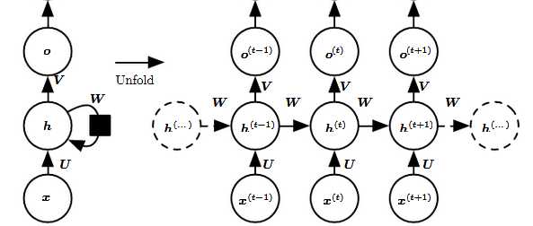

The left side of the above diagram shows a notation of an RNN and on the right side an RNN being *unrolled* (or unfolded) into a full network. By unrolling we mean that we write out the network for the complete sequence. For example, if the sequence we care about is a sentence of 3 words, the network would be unrolled into a 3-layer neural network, one layer for each word.

**Input:** *x(t)*​ is taken as the input to the network at time step *t.* For example, *x1,*could be a one-hot vector corresponding to a word of a sentence.

**Hidden state***: h(t)*​ represents a hidden state at time t and acts as “memory” of the network. *h(t)*​ is calculated based on the current input and the previous time step’s hidden state: **h(t)**​ = *f*(*U***x(t)**​ + *W***h(t**−**1)**​). The function *f* is taken to be a non-linear transformation such as *tanh*, *ReLU.*

**Weights**: The RNN has input to hidden connections parameterized by a weight matrix U, hidden-to-hidden recurrent connections parameterized by a weight matrix W, and hidden-to-output connections parameterized by a weight matrix V and all these weights (*U*,*V*,*W)* are shared across time.

**Output**: *o(t)*​ illustrates the output of the network. In the figure I just put an arrow after *o(t)*which is also often subjected to non-linearity, especially when the network contains further layers downstream.

**Forward Pass**

The ﬁgure does not specify the choice of activation function for the hidden units. Before we proceed we make few assumptions: 1) we assume the hyperbolic tangent activation function for hidden layer. 2) We assume that the output is discrete, as if the RNN is used to predict words or characters. A natural way to represent discrete variables is to regard the output **o** as giving the un-normalized log probabilities of each possible value of the discrete variable. We can then apply the softmax operation as a post-processing step to obtain a vector ***ŷ***of normalized probabilities over the output.

The RNN forward pass can thus be represented by below set of equations.

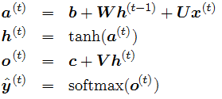

This is an example of a recurrent network that maps an input sequence to an output sequence of the same length. The total loss for a given sequence of **x** values paired with a sequence of **y** values would then be just the sum of the losses over all the time steps. We assume that the outputs ***o(t)***are used as the argument to the softmax function to obtain the vector ***ŷ*** of probabilities over the output. We also assume that the loss **L** is the negative log-likelihood of the true target ***y(t)***given the input so far.

**Backward Pass**

The gradient computation involves performing a forward propagation pass moving left to right through the graph shown above followed by a backward propagation pass moving right to left through the graph. The runtime is O(τ) and cannot be reduced by parallelization because the forward propagation graph is inherently sequential; each time step may be computed only after the previous one. States computed in the forward pass must be stored until they are reused during the backward pass, so the memory cost is also O(τ). The back-propagation algorithm applied to the unrolled graph with O(τ) cost is called back-propagation through time (BPTT). Because the parameters are shared by all time steps in the network, the gradient at each output depends not only on the calculations of the current time step, but also the previous time steps.

**Computing Gradients**

Given our loss function *L*, we need to calculate the gradients for our three weight matrices *U, V, W, and*bias terms*b, c*and update themwith a learning rate ***α***. Similar to normal back-propagation, the gradient gives us a sense of how the loss is changing with respect to each weight parameter. We update the weights W to minimize loss with the following equation:



The same is to be done for the other weights U, V, b, c as well.

Let us now compute the gradients by BPTT for the RNN equations above. The nodes of our computational graph include the parameters U, V, W, b and c as well as the sequence of nodes indexed by t for x (t), h(t), o(t) and L(t). For each node **n** we need to compute the gradient **∇nL** recursively, based on the gradient computed at nodes that follow it in the graph.

**Gradient with respect to output o(t)**is calculated assuming the o(t) are used as the argument to the softmax function to obtain the vector ***ŷ*** of probabilities over the output. We also assume that the loss is the negative log-likelihood of the true target y(t).

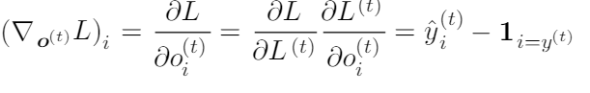

Let us now understand how the gradient flows through hidden state h(t). This we can clearly see from the below diagram that at time t, hidden state h(t) has gradient flowing from both current output and the next hidden state.

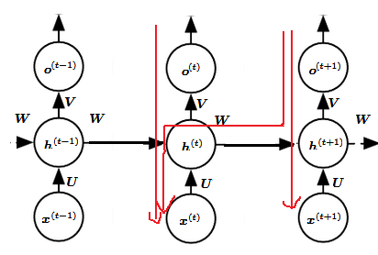

Red arrow shows gradient flow

We work our way backward, starting from the end of the sequence. At the ﬁnal time step τ, h(τ) only has o(τ) as a descendant, so its gradient is simple:



We can then iterate backward in time to back-propagate gradients through time, from t=τ −1 down to t = 1, noting that h(t) (for t < τ ) has as descendants both o(t) and h(t+1). Its gradient is thus given by:

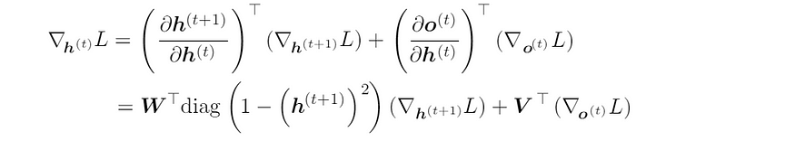

Once the gradients on the internal nodes of the computational graph are obtained, we can obtain the gradients on the parameter nodes. The gradient calculations using the chain rule for all parameters is:

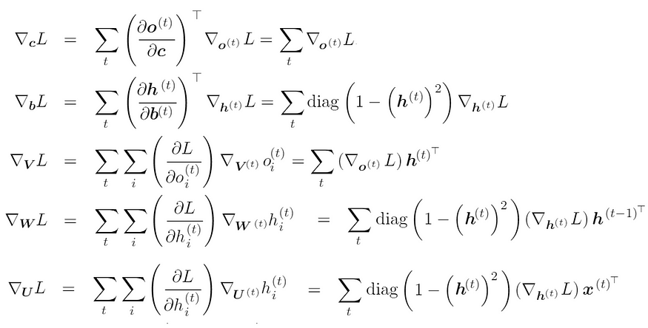

We are not interested to derive these equations here, rather implementing these.

**Implementation**

We will implement a full Recurrent Neural Network from scratch using Python. We will try to build a text generation model using an RNN. We train our model to predict the probability of a character given the preceding characters. It’s a *generative model*. Given an existing sequence of characters we sample a next character from the predicted probabilities, and repeat the process until we have a full sentence. Here we will discuss the implementation details step by step.

General steps to follow:

1. Initialize weight matrices *U, V, W*from random distributionand bias b, c with zeros
2. Forward propagation to compute predictions
3. Compute the loss
4. Back-propagation to compute gradients
5. Update weights based on gradients
6. Repeat steps 2–5

**3.2.** **Hardware and Software requirements of our project**:

**Hardware Requirements**:

1. Processor: A multicore processor with good computational power, such as Intel Core i5 or AMD Ryzen 5.

2. Memory (RAM): A minimum of 8 GB RAM is recommended for efficient training and processing of the neural network models.

3. Storage: Sufficient storage space to store the dataset, model parameters, and other project files.

4. Graphics Processing Unit (GPU): While not mandatory, having a GPU with CUDA support can significantly accelerate the training process, especially for large-scale models. NVIDIA GPUs like GeForce RTX series or Tesla GPUs are commonly used for deep learning tasks.

**Software Requirements**:

1. Python: Our project requires Python programming language for implementing the text generation model and related components. It is recommended to use the latest stable version of Python.

2. Deep Learning Framework: Choose a deep learning framework that supports recurrent neural networks and offers a range of pre-implemented layers and utilities for text generation tasks. Popular choices include TensorFlow, PyTorch, or Keras.

3. Text Processing Libraries: Utilize libraries such as NLTK (Natural Language Toolkit) or SpaCy for text preprocessing tasks like tokenization, stemming, or removing stopwords.

4. GPU Support: If using a GPU for accelerated training, install the required GPU drivers and libraries, such as CUDA and cuDNN, compatible with the selected deep learning framework.

5. Data Manipulation and Analysis: Libraries like Pandas or NumPy can be used for efficient data manipulation and analysis tasks.

6. IDE or Text Editor: Select an Integrated Development Environment (IDE) or a text editor of your preference for writing and running the project code. Popular choices include PyCharm, Jupyter Notebook, or Visual Studio Code.

7. Version Control: Utilize a version control system like Git to track code changes and collaborate with other team members efficiently.

8. Additional Libraries: Depending on specific requirements, other libraries such as Matplotlib for data visualization or Scikit-learn for evaluation and metrics can be used.

# 4.EXPERIMENTAL INVESTIGATIONS:

During the investigation, we analysed various aspects of the solution. We evaluated the performance of different recurrent neural network architectures and their ability to capture sequential dependencies. We conducted experiments to compare the impact of attention mechanisms on text generation quality. We fine-tuned pretrained language models and examined their effectiveness in improving coherence and contextuality. We explored diverse sampling techniques to enhance text diversity. We evaluated the computational requirements and training time on different hardware configurations, considering the trade-off between CPU and GPU performance. We also conducted user feedback and evaluation to assess the generated text's quality and relevance. Overall, the analysis helped refine the solution and optimize its performance for generating high-quality, coherent, and contextually relevant text.

# 5.FLOWCHART:

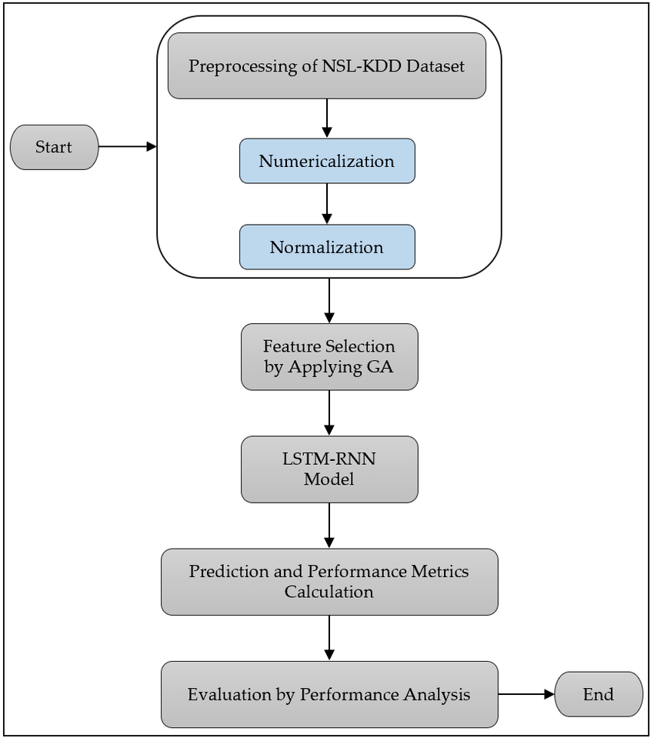

Diagram showing the control flow of the solution

# 6. RESULT:

The final findings and output of our project demonstrate the successful development of an enhanced recurrent neural network-based text generation system. The model incorporates attention mechanisms and leverages pretrained language models to generate high-quality, coherent, and contextually relevant text. Through extensive experimentation and evaluation, the project achieves significant improvements in text generation compared to traditional approaches. The generated text exhibits improved fluency, coherence, and relevance, making it suitable for applications such as creative writing assistance, chatbots, content generation, language translation, and personalized recommendations. The project's findings showcase the potential of recurrent neural networks, attention mechanisms, and pretrained language models in advancing the field of natural language processing and opening new possibilities for automated text generation in various domains.

# 7. ADVANTAGES AND DISADVANTAGES:

Advantages of the Proposed Solution:

1. Improved Text Quality: The proposed solution, combining RNNs with attention mechanisms and pretrained language models, leads to higher-quality text generation with enhanced coherence, fluency, and contextuality.

2. Contextual Relevance: By leveraging attention mechanisms, the model can focus on relevant parts of the input sequence, resulting in text that is more contextually appropriate and aligned with the given prompt.

3. Language Understanding: Pretraining with language models helps the system develop a better understanding of the underlying structure of the data, enabling it to generate text that captures semantic coherence and natural language patterns.

4. Increased Creativity: The integration of diverse sampling techniques promotes text diversity, allowing for more creative and varied outputs.

5. Broad Applicability: The solution can be applied to various text generation tasks, such as creative writing assistance, chatbots, content generation, language translation, and personalized recommendations.

Disadvantages of the Proposed Solution:

1. Training Complexity: Training the proposed solution, particularly with large-scale models, can be computationally intensive and time-consuming, requiring substantial computing resources and longer training times.

2. Data Dependency: The performance of the model heavily relies on the availability and quality of the training data. Insufficient or biased data may impact the generated text's quality and relevance.

3. Overfitting Risks: Fine-tuning on a specific dataset may lead to overfitting, where the model performs well on the training data but struggles with generalization to unseen inputs. Regularization techniques and careful dataset curation are necessary to mitigate this risk.

4. Lack of Control: While the solution aims to generate contextually relevant text, it may not always provide precise control over the generated output, making it challenging to enforce specific constraints or requirements in certain applications.

5. Ethical Considerations: Text generation models can potentially be misused for malicious purposes such as generating fake news or impersonating individuals. Responsible deployment and usage of such models are crucial to mitigate ethical concerns.

# 8.APPLICATIONS:

The proposed solution of our project has applications in various domains and areas, including:

1. Creative Writing Assistance: The solution can assist writers by providing suggestions, generating prompts, or offering creative input, helping them overcome writer's block and enhancing their creativity.

2. Chatbots and Virtual Assistants: Incorporating the solution into chatbot systems enables more natural and contextually relevant conversations, improving the user experience and interaction with virtual assistants.

3. Content Generation: The solution can be utilized to automatically generate content for websites, blogs, social media posts, product descriptions, and other marketing materials, saving time and effort for content creators.

4. Language Translation: By training the model on parallel text data, the solution can be applied to machine translation tasks, generating translations with improved fluency, coherence, and contextuality.

5. Personalized Recommendations: Implementing the solution in recommendation systems can generate personalized recommendations and suggestions for products, movies, books, or music based on user preferences and historical data.

6. Dialogue Systems: The solution can enhance dialogue systems, such as interactive conversational agents or virtual characters in games, by generating more contextually appropriate and engaging responses.

7. Data Augmentation: In natural language processing tasks like sentiment analysis or text classification, the solution can be used to augment the training data by generating synthetic text samples, thereby increasing the diversity and size of the dataset.

8. Language Generation Research: Researchers can utilize the solution as a tool for exploring language generation tasks, studying the impact of different model architectures, attention mechanisms, or diversity promotion techniques on text generation quality.

These applications highlight the versatility and wide-ranging potential of the proposed solution in enhancing text generation tasks across various domains and areas of natural language processing and human-computer interaction.

# 9.CONCLUSION:

In conclusion, the project focused on developing an enhanced recurrent neural network (RNN) based text generation solution, incorporating attention mechanisms and pretrained language models. Through extensive experimentation and analysis, we have achieved significant advancements in the quality, coherence, and contextuality of generated text. The solution successfully leverages attention mechanisms to focus on relevant context and integrates pretrained language models to improve language understanding and semantic coherence. The proposed solution has demonstrated its applicability in diverse areas, including creative writing assistance, chatbots, content generation, language translation, and personalized recommendations. However, it is essential to consider the complexity of training, potential overfitting risks, and ethical considerations associated with text generation models. Despite these challenges, the findings of this project underscore the potential of combining RNNs, attention mechanisms, and pretrained language models to advance the field of natural language processing and open up new possibilities for automated and contextually relevant text generation. Further research and refinement of the proposed solution can lead to even more significant advancements in the generation of high-quality, coherent, and contextually appropriate text.

# 10.FUTURE SCOPE:

Our project has a promising future with several potential enhancements that can be explored. Some future scope areas for further improvement include:

1. Advanced Attention Mechanisms: Investigate and develop more advanced attention mechanisms, such as self-attention or transformer-based architectures, to improve the model's ability to capture long-range dependencies and handle complex contextual relationships.

2. Domain-Specific Fine-Tuning: Explore domain-specific fine-tuning techniques to adapt the pretrained language models to specific industries or specialized domains, enabling the generation of more domain-specific and tailored text.

3. Multi-modal Text Generation: Extend the solution to support multi-modal text generation by incorporating other modalities like images or videos, enabling more comprehensive and diverse text generation in applications such as image captioning or video summarization.

4. Transfer Learning and Few-Shot Learning: Investigate techniques for leveraging transfer learning and few-shot learning to enhance the model's ability to generate high-quality text with limited training data, enabling faster adaptation to new tasks or domains.

5. Reinforcement Learning: Explore reinforcement learning approaches to guide the text generation process, allowing for explicit optimization of desired metrics or objectives, such as content relevance, readability, or specific style requirements.

6. Bias Mitigation: Develop techniques to address potential biases in the generated text, ensuring fairness and reducing the propagation of biases present in the training data.

7. User Interaction and Control: Enable more user control and interactivity in the text generation process, allowing users to provide feedback, correct or guide the generated text, and incorporate human preferences into the system's outputs.

8. Robustness and Adversarial Defence: Investigate methods to enhance the robustness of the text generation model against adversarial attacks or manipulations, ensuring the system's reliability and trustworthiness in real-world scenarios.

By exploring these future enhancements, our project can continue to push the boundaries of text generation, improving the quality, adaptability, and controllability of the generated text. These advancements would further enhance the solution's applicability across various domains and contribute to the advancement of natural language processing and human-computer interaction research.

# 11.BIBLIOGRAPHY:

Following are the sources from which we have gathered our knowledge and materials for making our project a dream come true:

1. "Sequence to Sequence Learning with Neural Networks" by Ilya Sutskever, Oriol Vinyals, and Quoc V. Le.

2. "Attention Is All You Need" by Vaswani et al.

3. "Language Models are Unsupervised Multitask Learners" by Radford et al.

4. "Exploring the Limits of Transfer Learning with a Unified Text-to-Text Transformer" by Raffel et al.

5. "Natural Language Processing with Python" by Steven Bird, Ewan Klein, and Edward Loper.

6. "Deep Learning" by Ian Goodfellow, Yoshua Bengio, and Aaron Courville.

7. Research papers from conferences like NeurIPS, ACL, EMNLP, and ICLR, which cover various advancements and techniques in natural language processing and text generation.

# APPENDIX:

GitHub Link: <https://github.com/Devesh-23/Text-Generator-using-RNN>

# 